**Task: Member Profile – Reference 2 hrs**

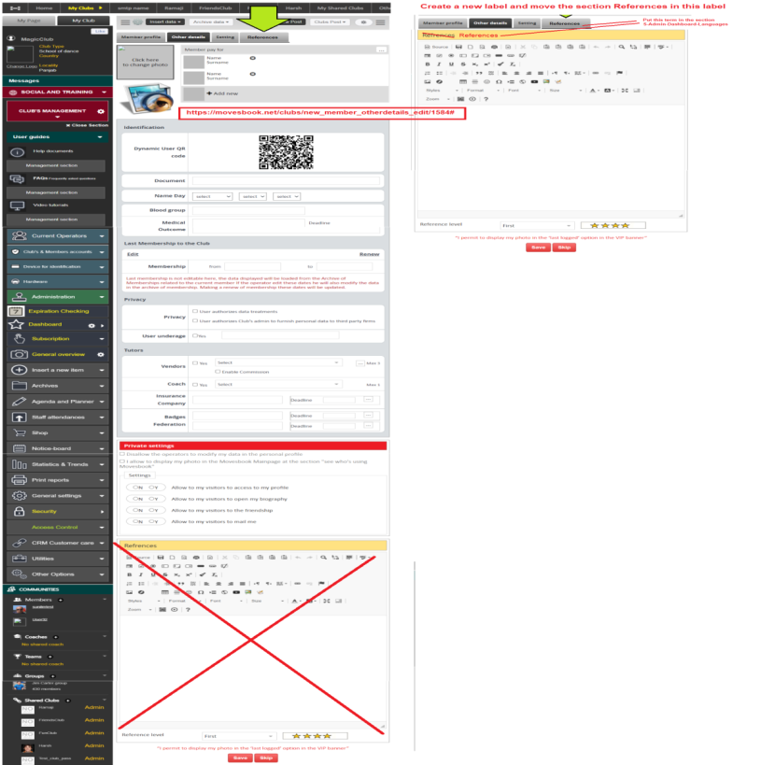

**======> C:\wamp\www\movesbook\app\View\Elements\club\club_newmember_tab_edit.ctp**

**----> // ZST Edit From**

**$member_references = "";**

**----> else if ($params["action"] == "club_member_references") {**

**$member_references = "active";**

**// $id="";**

**}**

**----> <li>**

**<?php**

**echo $this->Html->link("References", array("controller" => "clubs", "action" => "new_member_references_edit", $id), array('class' => $member_references));**

**?>**

**</li>**

**=====>C:\wamp\www\movesbook\app\View\Clubs\new_member_otherdetails_edit.ctp**

**Remove Below Code :-**

**---------------------**

**<div class="vip-section">**

**<h3>Refrences</h3>**

**<div class="reference-ck">**

**<?php**

**echo $this->Form->input('MemberOtherdetail.reference', array('type' => 'textarea', 'class' => 'ckeditor', 'label' => false, 'div' => array('class' => '')));**

**?>**

**</div>**

**<div class="vip-star">**

**<div class="col-30">Reference level</div>**

**<div class="col-30">**

**<div class="custom-select">**

**<?php**

**$referenceLevelArray = array(1 => 'First ', 2 => 'Second', 3 => 'Third', 4 => 'Fourth', 5 => 'Fifth', 6 => 'Sixth');**

**$TempreferenceLevelArray = array(1 => '<img src="' . $this->webroot . 'img/star-small.png">');**

**echo $this->Form->input('MemberOtherdetail.reference_level', array('options' => $referenceLevelArray, 'label' => false, 'div' => false, 'escape' => false));**

**?>**

**</div>**

**</div>**

**<div class="col-30">**

**<img src="<?= $this->webroot; ?>img/vip-start.jpg">**

**</div>**

**</div>**

**<div class="clear"></div>**

**</div>**

**Add To:--**

**--------**

**<div class="savecancel">**

**<p>“I permit to display my photo in the ‘last logged’ option in the VIP banner”</p>**

**<div class="text-center mt-10 mb-10">**

**<?php echo $this->Form->input($langs['Save'], array('type' => 'button', 'id' => '', 'class' => 'btn-red', 'onclick' => 'return(submit_memeber())', 'div' => false, 'label' => false, 'name' => 'submit', 'value' => 'submit')); ?>**

**<?php echo $this->Form->input("Skip", array('type' => 'button', 'id' => '', 'class' => 'btn-red', 'label' => false, 'name' => 'skip', 'div' => false, 'value' => 'skip')); ?>**

**<!--<button type="submit" name="submit" class="btn" onclick="onclick=>return(submit_memeber())" id="submit_form">Save</button>**

**<button type="submit" name="skip" class="btn" id="submit_form">Skip</button> -->**

**</div>**

**</div>**

**=====> C:\wamp\www\movesbook\app\Controller\ClubsController.php**

**new_member_references_edit**

**public function new_member_references_edit(){**

**.....}**

**Coding :**

